Stages of program compilation

In the language C we have four steps of compilation: preprocessing, compiling, assembly, linking. I will show with my words the steps.

Preprocessing: In this first step the machine will eliminate the comments, expanding included files and if we have any library in the code, the compilator will include the library in the program.

Compiling: The second step generates assembly language for the processor.

Assembly: In this step the compilator will convert the assembly code into pure binary code (machine code)

Linking: in the final step, the linker merges all the machine code from multiple modules into a single one.

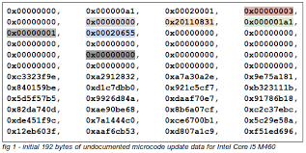Levels of programming Language

Microcode: Machine-specific code that directs the individual components of a CPU’s data-path to perform small-scale operations.

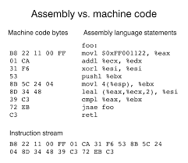• Machine code: Machine-specific code that directs the individual components of a CPU’s data-path to perform small-scale operations.

• Assembly Language: Assembly language is a symbolic presentation of machine code so that people (very dedicated people with lots of free time) can read programs written in it.

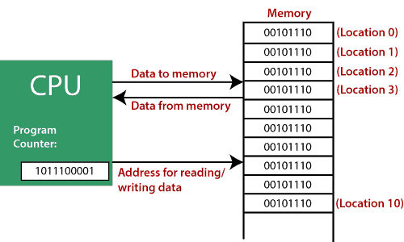• Low-level Programming Language: FORTRAN, COBOL, BASIC, arguably C. These languages have looping constructs, procedures, functions, some typing – the trappings of modern programming languages.

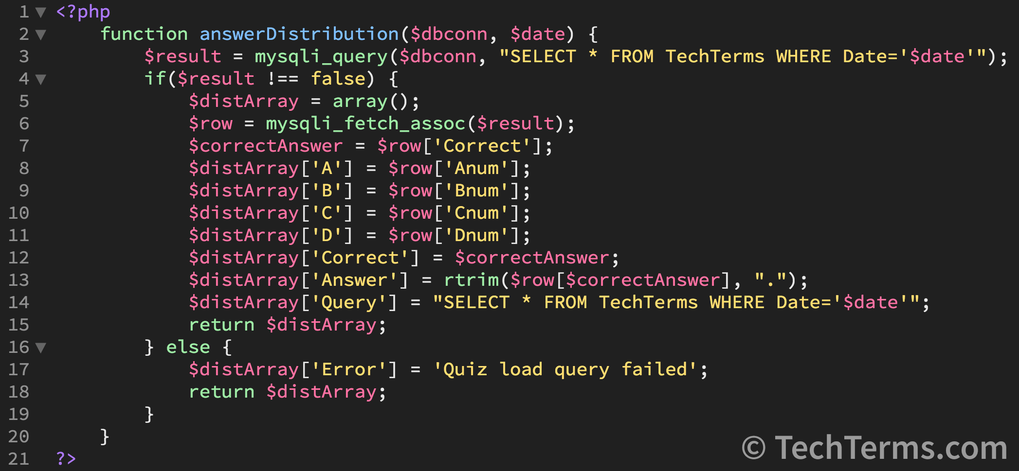• High-level Programming Language: Java, Python, ML, Prolog, MATLAB, etc. Java, Python, ML, Prolog, MATLAB, etc

Leung, W (September 12th of 2018) How the Compilation Process Works for C Programs. *Data Driven investor https://medium.datadriveninvestor.com/compilation-process-db17c3b58e62*